Introduction

At the end of this Chapter, the learner will be able to:

* Learn how to convert functional needs to a conceptual data model
* Identify the main concepts of the Entity-relationship model

Entity / Relationship model

* The Entity-relationship model is a type of conceptual diagram widely used for databases data, including relational databases.
* It is a tool for describing the structure of a database by highlighting many concepts:
  + Entity
  + Relation
  + Cardinalities
  + Attributes / Identifier
  + etc.

Entity

* An entity is an abstract representation of a real world object.
* An entity represents a physical or logical object.
* The object which will be represented with an entity must have different characteristics.

Attributes

* Each entity is described based on a list of properties which characterize the entity.
* At this level, the attributes are defined with their names (designation). It is not necessary to identify types of the different attributes

Entity Identifier

* An entity identifier is a property (attribute) which can qualify an occurrence of an entity.
* The entity identifier can be simple or composed of multiple attributes.
* An entity identifier is assigned to each entity upon creation.

Relationship

* A relationship represents links between entity occurrences.
* Several employees works in the department “department_1”.
* The relationship models the relation or association between department and employee entities

# Relationship

A relationship can have more information (attributes)

Cardinalities

* Cardinalities are among the properties of an association.
* In DBMS, cardinality refers to the relationship between two entities. We should have two terms of cardinalities, on the side of each entity.
* It models the number of times (minimum-maximum) of participation of the entity in the relationship.
* The minimum value is either 0 or 1 and the maximum value varies between 1 and N

Cardinalities

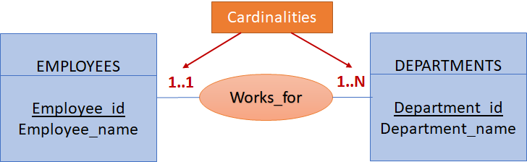

* One employee works in one department
* A department hires between one and N employees
* There are 4 types of cardinalities : **0..1, 0..N, 1..1, 1..N**

Relationship types

* The type of a given relationship can be identified based on the cardinalities of each side.
* There are 3 types of relationship:
  + OnetoOne **(1..1)**
  + OnetoMany **(1..N)**
  + ManytoMany **(N..N)**

Works_for” is OnetoMany relationship.

Sub-Entity

* A sub-entity expresses the notion of inheritance.
* Sub-entities inherit attributes from the parent class with some specifications which are those attributes.

Weak entity

* An entity that cannot be uniquely identified by its own attributes and relies on the relationship with other entity is called weak entity.
* A weak entity is an entity without identifier which depends on another so-called strong entity.
* The weak entity is represented by a double rectangle.

# Reflexive relation

A reflexive association is a binary association which involves the same entity twice.

n-ary relationship

* In an n - ary relationship, the n shows the number of entities in the relationship.
* If n=1, we get a reflexive relation, if n=2, it is a binary relation which links between 2 entities.
* if n>2, we talk about n-ary relationship, which involves three or more entities.

RECAP

* The entity relationship model is a conceptual model
* The entity relationship model is based on:
  + Entities (Attributes and identifier)
  + Relationships which links between entities
  + Cardinalities
  + Relationship types